**Florida State Emergency Response Commission (SERC) Training Task Force (TTF)**

**Electric Vehicle Lithium-ion Battery 1st Responder Working Group**

* Lithium-Ion help files sent by team members

Vapor cloud explosion involving a plug-in hybrid EV - YouTube  
[https://www.youtube.com/watch?v=PNuSUsvnxEA](https://gcc02.safelinks.protection.outlook.com/?url=https%3A%2F%2Fwww.youtube.com%2Fwatch%3Fv%3DPNuSUsvnxEA&data=05%7C01%7CRobert.Dietrich%40em.myflorida.com%7C8a8865bf1eb54ae4b5b308db83c56ab6%7C9ce0de61985749a2b40c3a9cb9f8f4dc%7C0%7C0%7C638248656164758856%7CUnknown%7CTWFpbGZsb3d8eyJWIjoiMC4wLjAwMDAiLCJQIjoiV2luMzIiLCJBTiI6Ik1haWwiLCJXVCI6Mn0%3D%7C3000%7C%7C%7C&sdata=FrqYZ62OGOVYaVQsReZtS1ajAFlfiABhsuWKWViLjro%3D&reserved=0)  
[https://m.youtube.com/watch?v=PNuSUsvnxEA](https://gcc02.safelinks.protection.outlook.com/?url=https%3A%2F%2Fm.youtube.com%2Fwatch%3Fv%3DPNuSUsvnxEA&data=05%7C01%7CRobert.Dietrich%40em.myflorida.com%7C8a8865bf1eb54ae4b5b308db83c56ab6%7C9ce0de61985749a2b40c3a9cb9f8f4dc%7C0%7C0%7C638248656164758856%7CUnknown%7CTWFpbGZsb3d8eyJWIjoiMC4wLjAwMDAiLCJQIjoiV2luMzIiLCJBTiI6Ik1haWwiLCJXVCI6Mn0%3D%7C3000%7C%7C%7C&sdata=eJc18n41fzoNjWktCu6oKtKm6nNChFVswcINiqHK9G0%3D&reserved=0)

One suggestion I had, which may have already been done, is to have Fire Rescue reach out to the Fire Departments in the Sates where the Tesla Gigafactories are located, and see what their tactics and procedures are, should they have to respond to an incident at these locations.  I’m sure their SOP’s are fairly stout and well planned.

Tesla Gigafactory – Austin, TX & Buffalo, NY

Tesla Lithium Refinery – Robstown, TX

Tesla Powerwall, Powerpack, & Megapack Factories – Buffalo, NY & Storey County, Nevada

These are just ideas where one of our representatives can reach out to the local FD’s in the vicinity to gain expertise on how they are set up to fight a fire or respond in the event of a major incident

*FDNY Training Division tested the firefighters bunker gear after their EV fires and found traces of Hydrogen Fluoride (HF) in the gear. NOT GOOD! These EV fires were fought with copious of water and these test show that if it’s safer sometimes to Let Them Burn. When offensive water is applied the firefighters have get up-close to be effective with the attack lines, during this same time the firefighters are getting splash backs of contaminated water throughout their bunker gear during the incidents. Firefighters rarely ever leave a vehicle fire incident DRY……….*

Tesla is recalling certain 2023 Model 3 and Model Y vehicles due to defective pyrotechnic battery disconnect.  A defective battery disconnect may not isolate the vehicle’s high voltage battery after a crash or fault detection, increasing the risk of electrical shock and injury.  This could also potentially affect operations crews responding to these vehicles.

NOTICES

Meetings: **Consumer Product Safety Commission**

Lithium-Ion Battery Safety,

37042–37044 [2023–11981]

[2023-11981.pdf (govinfo.gov)](https://gcc02.safelinks.protection.outlook.com/?url=https%3A%2F%2Fwww.govinfo.gov%2Fcontent%2Fpkg%2FFR-2023-06-06%2Fpdf%2F2023-11981.pdf&data=05%7C01%7Crobert.dietrich%40em.myflorida.com%7Cbbcacd9c865c46cd2fe708db669c0933%7C9ce0de61985749a2b40c3a9cb9f8f4dc%7C0%7C0%7C638216592927358894%7CUnknown%7CTWFpbGZsb3d8eyJWIjoiMC4wLjAwMDAiLCJQIjoiV2luMzIiLCJBTiI6Ik1haWwiLCJXVCI6Mn0%3D%7C3000%7C%7C%7C&sdata=rxIS2p2vN%2BTgXc1%2FDZuvkGvZ4f0kfUsSjNQuHZUFXio%3D&reserved=0)

With June’s [Safety Stand Down](https://gcc02.safelinks.protection.outlook.com/?url=https%3A%2F%2Fwww.safetystanddown.org%2F&data=05%7C01%7CRobert.Dietrich%40em.myflorida.com%7C56c494a5734d4a5750e708db52eae115%7C9ce0de61985749a2b40c3a9cb9f8f4dc%7C0%7C0%7C638194940992524611%7CUnknown%7CTWFpbGZsb3d8eyJWIjoiMC4wLjAwMDAiLCJQIjoiV2luMzIiLCJBTiI6Ik1haWwiLCJXVCI6Mn0%3D%7C3000%7C%7C%7C&sdata=U%2F%2FQOYuXScPkFbaBhCrDtnvlCduJaQHFy7DRosyX%2Bfk%3D&reserved=0) theme being lithium-ion batteries, a good deal of information will be coming out about how to safely attack those fires. We’ve seen numerous vehicle and other battery fires. And, hazmat teams have been called out when fires or other incidents happen at power storage stations, which use large banks of lithium-ion batteries. In late April, hazmat teams responded to yet a different lithium-ion battery threat. Fire and hazmat crews in Jacksonville, Fla., responded to the Saft battery plant when one 20,000 pound lithium-ion battery caught fire. Jacksonville Fire Deputy Division Chief of Operations Mike Lesniak told the [Florida Times-Union](https://gcc02.safelinks.protection.outlook.com/?url=https%3A%2F%2Fwww.jacksonville.com%2Fstory%2Fnews%2Fcrime%2F2023%2F04%2F25%2Fhazmat-crews-contain-saft-battery-plant-fire-in-jacksonville%2F70151045007%2F&data=05%7C01%7CRobert.Dietrich%40em.myflorida.com%7C56c494a5734d4a5750e708db52eae115%7C9ce0de61985749a2b40c3a9cb9f8f4dc%7C0%7C0%7C638194940992524611%7CUnknown%7CTWFpbGZsb3d8eyJWIjoiMC4wLjAwMDAiLCJQIjoiV2luMzIiLCJBTiI6Ik1haWwiLCJXVCI6Mn0%3D%7C3000%7C%7C%7C&sdata=%2BMmmwiSJ1BgMlAc5eG21X6hZ4n1dVBP3dVyrLSQPWrI%3D&reserved=0) that there were no explosions, but the site was evacuated.

“These batteries, whether it’s the lithium-iron phosphate or lithium-ion batteries, they’re small cells, they’re packed together real tight,” Lesniak told the paper. “So what happens is once you get thermal runaway with one battery, then it impacts all the other batteries and compromises them. So it is not anything that you can put out with just putting a lot of water on them. … Once one battery gets going, it just heats up the battery next to it and around it.”

**Also Read**: [FDNY Shares Fire, Hazmat Lessons on Lithium-Ion Batteries](https://gcc02.safelinks.protection.outlook.com/?url=https%3A%2F%2Fwww.hazmatnation.com%2Fnews%2Ffdny-shares-fire-hazmat-lessons-on-lithium-ion-batteries%2F&data=05%7C01%7CRobert.Dietrich%40em.myflorida.com%7C56c494a5734d4a5750e708db52eae115%7C9ce0de61985749a2b40c3a9cb9f8f4dc%7C0%7C0%7C638194940992524611%7CUnknown%7CTWFpbGZsb3d8eyJWIjoiMC4wLjAwMDAiLCJQIjoiV2luMzIiLCJBTiI6Ik1haWwiLCJXVCI6Mn0%3D%7C3000%7C%7C%7C&sdata=MQICVCO0%2FHi8xFhxQYZDl2dp1IiRQ9rRP02WzeYm%2BV8%3D&reserved=0)

The initial attempts to put out the 20,000 pound battery with dry chemicals and special fire extinguishers were unsuccessful. Hazmat units worked to move the other nearby batteries and keep them cooled to not exacerbate the situation while the fire steadily burned the affected battery. “This fire continues to burn and it’s going to continue to burn for hours. It puts off some pretty dangerous gas,” Jacksonville Fire Chief Keith Powers told the paper, noting hydrogen fluoride.

**Also Read:**[Illegal Lithium Battery Transport Burn Just Before Going to Sea](https://gcc02.safelinks.protection.outlook.com/?url=https%3A%2F%2Fwww.hazmatnation.com%2Fnews%2Fillegal-lithium-battery-transport-burn-just-before-going-to-sea%2F&data=05%7C01%7CRobert.Dietrich%40em.myflorida.com%7C56c494a5734d4a5750e708db52eae115%7C9ce0de61985749a2b40c3a9cb9f8f4dc%7C0%7C0%7C638194940992524611%7CUnknown%7CTWFpbGZsb3d8eyJWIjoiMC4wLjAwMDAiLCJQIjoiV2luMzIiLCJBTiI6Ik1haWwiLCJXVCI6Mn0%3D%7C3000%7C%7C%7C&sdata=dC9FrEgFicQre3QlROYINSxfYfhpP%2Fgsk4LS5B5Suhg%3D&reserved=0)

Firefighters and hazmat crews were decontaminated after leaving the hot zone. More common will be incidents at energy storage system sites that use lithium-ion batteries.

ESS is essentially any system that can store energy for later use. The United States built its first ESS facility in 1929 and got serious about the technology during the 1970s’ oil crisis. Today, the push for renewable energy and the development of lithium-ion batteries catapulted the drive for more ESSs. Currently there are about [600 facilities in the U.S](https://gcc02.safelinks.protection.outlook.com/?url=https%3A%2F%2Fsandia.gov%2Fess-ssl%2Fgesdb%2Fpublic%2Fprojects.html&data=05%7C01%7CRobert.Dietrich%40em.myflorida.com%7C56c494a5734d4a5750e708db52eae115%7C9ce0de61985749a2b40c3a9cb9f8f4dc%7C0%7C0%7C638194940992524611%7CUnknown%7CTWFpbGZsb3d8eyJWIjoiMC4wLjAwMDAiLCJQIjoiV2luMzIiLCJBTiI6Ik1haWwiLCJXVCI6Mn0%3D%7C3000%7C%7C%7C&sdata=LRbxiqUmidAV6p2XJtw37Mm8VmyN1chG4KyypvVYB5Y%3D&reserved=0). We can expect that number to grow. We can expect it to grow beyond the massive sites storing energy from solar or wind farms in the deserts. We can expect to see smaller ESSs in urban areas, probably on rooftops.

**Also Read:**[Four Tips to Prepare for Energy Storage System Incidents](https://gcc02.safelinks.protection.outlook.com/?url=https%3A%2F%2Fwww.hazmatnation.com%2Fnews%2Ffour-tips-to-prepare-for-energy-storage-system-incidents%2F&data=05%7C01%7CRobert.Dietrich%40em.myflorida.com%7C56c494a5734d4a5750e708db52eae115%7C9ce0de61985749a2b40c3a9cb9f8f4dc%7C0%7C0%7C638194940992680822%7CUnknown%7CTWFpbGZsb3d8eyJWIjoiMC4wLjAwMDAiLCJQIjoiV2luMzIiLCJBTiI6Ik1haWwiLCJXVCI6Mn0%3D%7C3000%7C%7C%7C&sdata=tLAIfaEKKzRpaubyQmIYJlDSltA6KkrnMq1o71dH6bE%3D&reserved=0)

In its special report “[Learning from Surprise](https://gcc02.safelinks.protection.outlook.com/?url=https%3A%2F%2Fwww.nfpa.org%2FNews-and-Research%2FPublications-and-media%2FNFPA-Journal%2F2021%2FFall-2021%2FFeatures%2FESS&data=05%7C01%7CRobert.Dietrich%40em.myflorida.com%7C56c494a5734d4a5750e708db52eae115%7C9ce0de61985749a2b40c3a9cb9f8f4dc%7C0%7C0%7C638194940992680822%7CUnknown%7CTWFpbGZsb3d8eyJWIjoiMC4wLjAwMDAiLCJQIjoiV2luMzIiLCJBTiI6Ik1haWwiLCJXVCI6Mn0%3D%7C3000%7C%7C%7C&sdata=QnHCf5BaZGWbss23bkUP%2B0RMvWp%2FCb3D5SQBbpDoVSE%3D&reserved=0)”, NFPA did an outstanding job of detailing exactly what can go wrong for hazmat and fire responders. In April 2019 in Surprise, Arizona four firefighters were badly hurt when a lithium-ion ESS exploded. That explosion was preceded by what’s known as thermal runaway where the batteries rapidly discharged. That runaway increases heat and can lead to fire if unchecked. It also produces a cocktail of nasty gases.

Here are four steps you can take to better protect your hazmat team.

**ONE**

Learn as much as you can about ESSs and lithium-ion batteries. One of the Surprise hazmat members injured was an expert in this technology and was still caught off guard. [Learn and continue learning](https://gcc02.safelinks.protection.outlook.com/?url=https%3A%2F%2Fcss.umich.edu%2Ffactsheets%2Fus-grid-energy-storage-factsheet&data=05%7C01%7CRobert.Dietrich%40em.myflorida.com%7C56c494a5734d4a5750e708db52eae115%7C9ce0de61985749a2b40c3a9cb9f8f4dc%7C0%7C0%7C638194940992680822%7CUnknown%7CTWFpbGZsb3d8eyJWIjoiMC4wLjAwMDAiLCJQIjoiV2luMzIiLCJBTiI6Ik1haWwiLCJXVCI6Mn0%3D%7C3000%7C%7C%7C&sdata=kHE6I1LSdkIQL6gkbftCEIIyMUFK5x6T%2FzSPeJCbxr4%3D&reserved=0); this is a fast-evolving technology and field.

**TWO**

Get involved at the planning stage. According to NFPA, one of the key lessons from Surprise was to develop response plans and safety systems during the design and implementation phase of these ESS projects. NFPA reported that the emergency response plan did not convey that a large flammable gas hazard or cell-to-cell and module-to-module cascading thermal runaway was possible. “An up-to-date history of the measurements of gas composition and potentially the percent LEL inside the structure would have been the best information for the firefighters on scene, and undoubtedly would have changed their response and would have prevented the injuries,” Co-author of the UL report Mark McKinnon told NFPA Journal.

**THREE**

Push for code creation where needed and code enforcement where they exist. NFPA points to areas where its existing codes could have helped in Surprise and areas where codes need to adapt to this changing technology. Jim Biggins, the chair of the [NFPA 855](https://gcc02.safelinks.protection.outlook.com/?url=https%3A%2F%2Fwww.nfpa.org%2Fcodes-and-standards%2Fall-codes-and-standards%2Flist-of-codes-and-standards%2Fdetail%3Fcode%3D855&data=05%7C01%7CRobert.Dietrich%40em.myflorida.com%7C56c494a5734d4a5750e708db52eae115%7C9ce0de61985749a2b40c3a9cb9f8f4dc%7C0%7C0%7C638194940992680822%7CUnknown%7CTWFpbGZsb3d8eyJWIjoiMC4wLjAwMDAiLCJQIjoiV2luMzIiLCJBTiI6Ik1haWwiLCJXVCI6Mn0%3D%7C3000%7C%7C%7C&sdata=OBI5w%2Ffz5qUGksHenJiNobNedKZqt2TWvlaKbkVuDY8%3D&reserved=0) technical committee, says, “We’re looking at providing additional guidance in NFPA 855 both for explosion venting and normal venting of the battery enclosures and battery rooms. It’s such a large volume of gas coming out of a single cell during thermal runaway, and I don’t think anybody fully understood that mechanism previously.”

**FOUR**

Be wary of cure-all safety technology and one-stop training. This area will require careful research. New safety technology for hazmat and fire responders will need to be fully vetted. And training on best practices is sure to change often. “What happens a lot with new technology is there’s an expectation that the fire department immediately becomes an expert on how to mitigate a hazard that they respond to, and I don’t think that’s a fair expectation,” Kerber told NFPA. “There has to be research upfront, there have to be codes and standards in place, and sometimes the technology gets ahead of that. In this case, there was really no good guidance. There was no good training.”

*Original post – Copyright © 2023 HazmatNation.com. Externally linked references may hold their own independent copyright not assumed by HazmatNation*

[https://www.osha.gov/sites/default/files/publications/shib011819.pdf](https://gcc02.safelinks.protection.outlook.com/?url=https%3A%2F%2Fwww.osha.gov%2Fsites%2Fdefault%2Ffiles%2Fpublications%2Fshib011819.pdf&data=05%7C01%7CRobert.Dietrich%40em.myflorida.com%7C674695b02b9c4aa949a508db47e4cb13%7C9ce0de61985749a2b40c3a9cb9f8f4dc%7C0%7C0%7C638182820219075121%7CUnknown%7CTWFpbGZsb3d8eyJWIjoiMC4wLjAwMDAiLCJQIjoiV2luMzIiLCJBTiI6Ik1haWwiLCJXVCI6Mn0%3D%7C3000%7C%7C%7C&sdata=d9ob4WyxKesT%2BgV%2BEk8YpDSGDNUj%2FuKyvl8lfMx8uwo%3D&reserved=0)

[https://cfpa-e.eu/container-puts-out-inextinguishable-fires-in-electric-cars/](https://gcc02.safelinks.protection.outlook.com/?url=https%3A%2F%2Fcfpa-e.eu%2Fcontainer-puts-out-inextinguishable-fires-in-electric-cars%2F&data=05%7C01%7CRobert.Dietrich%40em.myflorida.com%7C674695b02b9c4aa949a508db47e4cb13%7C9ce0de61985749a2b40c3a9cb9f8f4dc%7C0%7C0%7C638182820219075121%7CUnknown%7CTWFpbGZsb3d8eyJWIjoiMC4wLjAwMDAiLCJQIjoiV2luMzIiLCJBTiI6Ik1haWwiLCJXVCI6Mn0%3D%7C3000%7C%7C%7C&sdata=a8JXsd%2ByAZ7RpdwhFwY1bUGugCPgWrRpEQdx9209PLc%3D&reserved=0)

[https://www.wikihow.com/Put-Out-a-Cell-Phone-Fire](https://gcc02.safelinks.protection.outlook.com/?url=https%3A%2F%2Fwww.wikihow.com%2FPut-Out-a-Cell-Phone-Fire&data=05%7C01%7CRobert.Dietrich%40em.myflorida.com%7C674695b02b9c4aa949a508db47e4cb13%7C9ce0de61985749a2b40c3a9cb9f8f4dc%7C0%7C0%7C638182820219075121%7CUnknown%7CTWFpbGZsb3d8eyJWIjoiMC4wLjAwMDAiLCJQIjoiV2luMzIiLCJBTiI6Ik1haWwiLCJXVCI6Mn0%3D%7C3000%7C%7C%7C&sdata=1Hy7zuIaiPZJ%2FTFiYRLEkqii6BDr8pku3LgXR3Q1nEU%3D&reserved=0)

<https://www.amazon.com/BAT-SAFE-LiPo-Battery-Charging-Painted/dp/B07ZPKKF26/ref=asc_df_B07ZPKKF26/?tag=hyprod-20&linkCode=df0&hvadid=475811497606&hvpos=&hvnetw=g&hvrand=17907847724801809091&hvpone=&hvptwo=&hvqmt=&hvdev=c&hvdvcmdl=&hvlocint=&hvlocphy=9011610&hvtargid=pla-996765110396&psc=1>

containers used for lithium fire battery fires

[https://www.avdfire.com/products/fire-resistant-battery-container/](https://gcc02.safelinks.protection.outlook.com/?url=https%3A%2F%2Fwww.avdfire.com%2Fproducts%2Ffire-resistant-battery-container%2F&data=05%7C01%7CRobert.Dietrich%40em.myflorida.com%7C674695b02b9c4aa949a508db47e4cb13%7C9ce0de61985749a2b40c3a9cb9f8f4dc%7C0%7C0%7C638182820219075121%7CUnknown%7CTWFpbGZsb3d8eyJWIjoiMC4wLjAwMDAiLCJQIjoiV2luMzIiLCJBTiI6Ik1haWwiLCJXVCI6Mn0%3D%7C3000%7C%7C%7C&sdata=oMPiiMbXWdtXzZj8Q3H0CZw4IFB4OXhcyVxJbCs0p4k%3D&reserved=0)

Electric car fire container

[https://brandogsikring.dk/en/news/2020/container-puts-out-inextinguishable-fires-in-electric-cars/](https://gcc02.safelinks.protection.outlook.com/?url=https%3A%2F%2Fbrandogsikring.dk%2Fen%2Fnews%2F2020%2Fcontainer-puts-out-inextinguishable-fires-in-electric-cars%2F&data=05%7C01%7CRobert.Dietrich%40em.myflorida.com%7C674695b02b9c4aa949a508db47e4cb13%7C9ce0de61985749a2b40c3a9cb9f8f4dc%7C0%7C0%7C638182820219075121%7CUnknown%7CTWFpbGZsb3d8eyJWIjoiMC4wLjAwMDAiLCJQIjoiV2luMzIiLCJBTiI6Ik1haWwiLCJXVCI6Mn0%3D%7C3000%7C%7C%7C&sdata=JhGGhSLFSJNfr%2F23lnwo5YQu6dYsQ2JvlVankqbR1uk%3D&reserved=0)

CONTAINER PUTS OUT INEXTINGUISHABLE FIRES IN ELECTRIC CARS

*Published 08.03.20*

The lithium-ion batteries in electric and hybrid cars present a challenge to the emergency services if the cars are involved in a traffic accident or burst into flames. Now, the emergency services in Denmark have developed their own solution.

Cars can burst into flames a long time after they have been damaged. They can be exceptionally difficult to extinguish. They can flare up again and again. They emit combustible and harmful gases. Water is contaminated and damaging to the environment due to chemicals. Yes, the batteries in electric and hybrid cars present numerous challenges when you look at it from the point of view of the emergency services. This is the conclusion of a new report from the Swedish organisation RISE, which has taken a closer look at lithium-ion batteries in vehicles. The numerous factors specific to electric and hybrid cars present the emergency services with a number of challenges, which the emergency services in Copenhagen are now tackling. They have designed a container specifically for handling damaged electric and hybrid cars.- We are seeing more and more electric and hybrid cars in the municipalities we cover. And, it would appear that there will be many more in the future. That is why we must be able to deal with the chemical fires they can cause, says Michael Kim Andersen, Deputy Director of Emergency Services in Copenhagen.

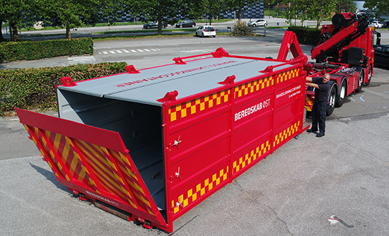

A well-equipped container

The individual cells in a lithium-ion batter can be damaged in the event of a traffic accident or if there is a fire in the car. This can result in the development of heat in the cell, which then spreads from cell to cell – also known as thermal runaway. A chemical fire in a lithium-ion battery can develop very quickly with shooting flames and harmful flammable gases. Heat can develop several hours after an accident has occurred, and if one cell has thermal runaway, the heat from that cell can cause the neighbouring cell to develop heat too. This way, a single cell can start a chain reaction which can cause the battery to burst into flames a long time after an accident has taken place. The effects of heat from, for example, a fire, can result in the same effect in a cell.

- Batteries are difficult to extinguish, and they can burst into flames again several hours later – in some cases, right up to a week later. We can't close roads and motorways for several hours, so if it isn't possible for us to extinguish the fire in the battery, we may have to remove the car. That's why we have developed a container for that very purpose, says Michael Kim Andersen. The container is constructed in such a way that you lift or tow an electric car into it, place the container on the bed of a tow truck and remove the car. The container has nozzles in the floor and on the walls which can be used to both extinguish any flames and cool the battery - which more often than not, is located under the car - to hamper the development of heat. The water for the nozzles flows round a circuit, which reduces water consumption significantly and makes it easier to collect the water later and send it for cleansing if it has been contaminated by chemicals from the battery. In addition, there are installations with inert gas in the container.

- A fire in an electric car battery is a chemical fire and does not require oxygen. Therefore, inert gas has no effect on the battery but is intended for the other parts of the car. Indeed, the development of heat from the battery can potentially cause the cabin to burst into flames. And since it's a confined space – at least until the windows burst – the water can't get in there. Therefore, inert gas is required to smother the flames, explains Michael Kim Andersen.

Extended period of isolation required

With the container, the procedure in the event of an accident with an electric or hybrid car will be more or less the same as an accident involving conventional cars. It is cleared up quickly and the traffic can keep flowing. However, an electric car can't be taken to a car breaker or a workshop where it is placed indoors next to other cars, which a fire could potentially spread to. Instead, it can now be left in the container until the risk of it flaring up has subsided.

- We are in dialogue with other authorities to determine where we can put the container when it contains a damaged electric or hybrid car. It must be kept in an isolated and closed area where it can remain undisturbed for a time, says Michael Kim Andersen.

Requires extra vigilance

The container is the only one of its kind in the Nordic region, and the interest in it is high from neighboring emergency services, who can requisition it on an equal footing with other cars and from abroad. However, it doesn't meet the challenges presented by electric and hybrid cars on its own. Poisonous gases from the batteries mean that special procedures are required when the fire brigade arrive at fires in electric cars.

- If there is a fire in an electric or hybrid car, we are acutely aware that the smoke may contain hydrogen fluoride, which is extremely harmful. Even small doses can result in water in the lungs. Therefore, we also take the precaution of using fresh air breathing apparatus from a greater distance than we would in a normal car fire, says Michael Kim Andersen.

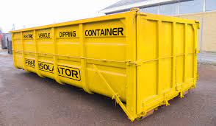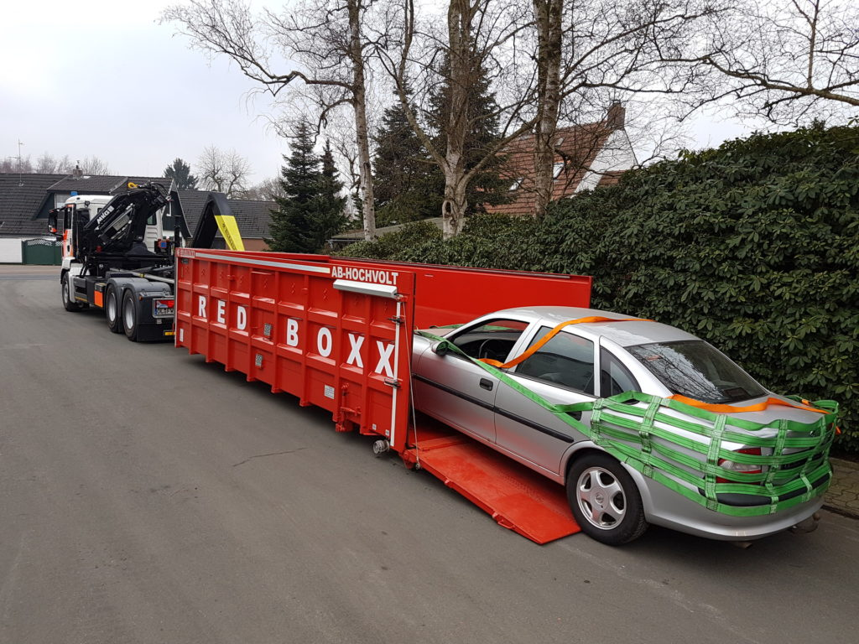

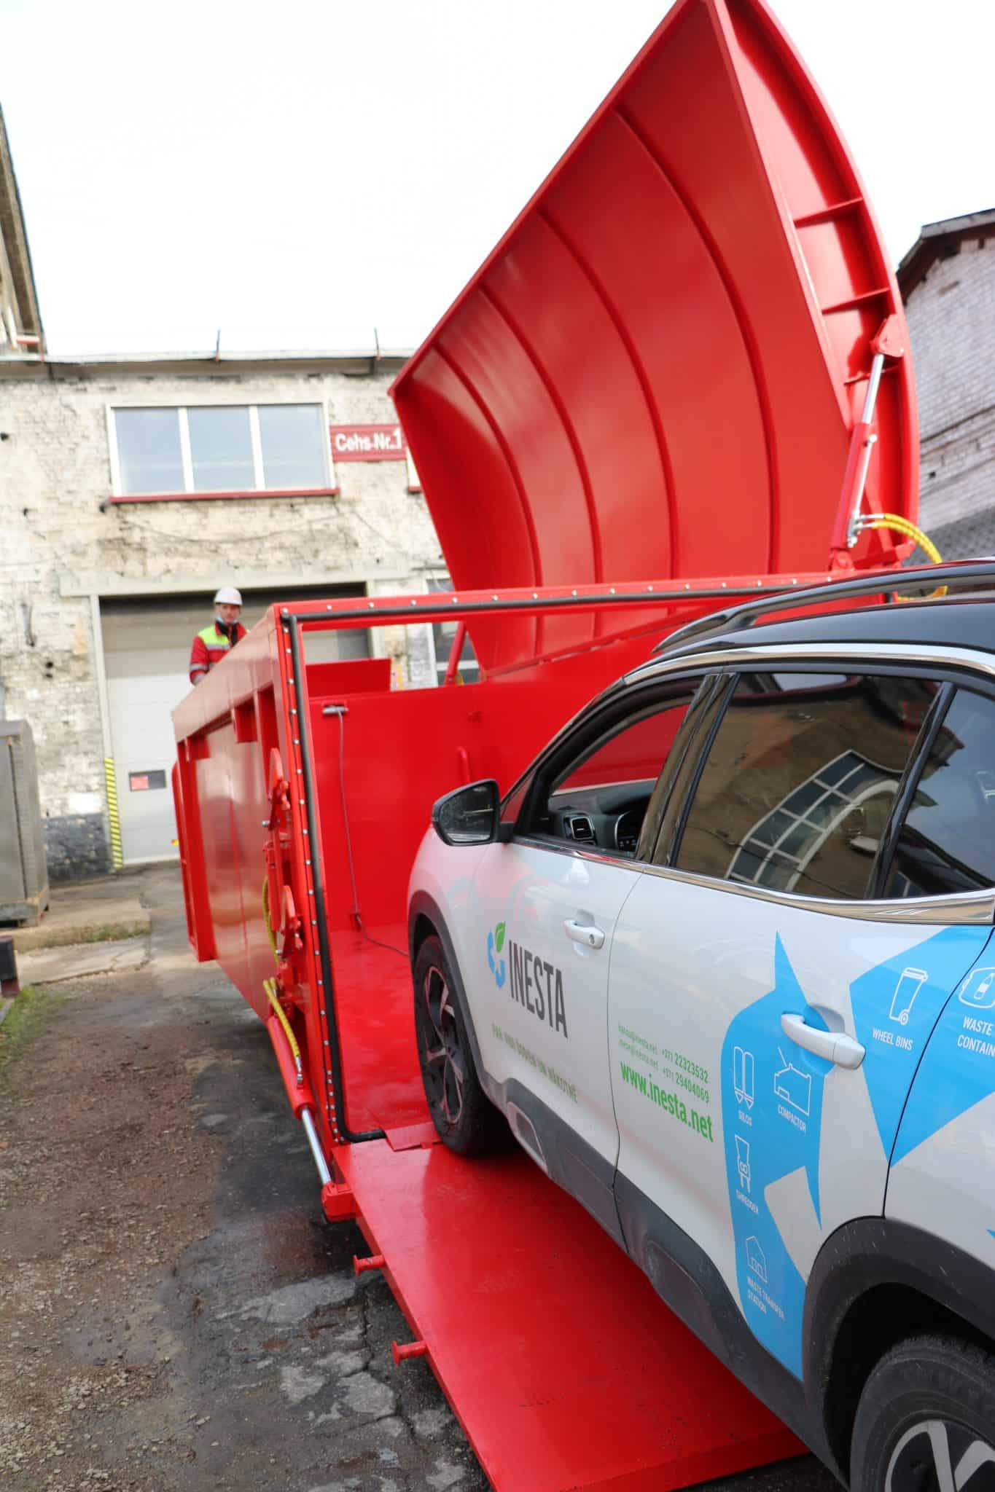

[https://arstechnica.com/gadgets/2022/12/recycling-firm-fined-after-tossed-batteries-cause-garbage-truck-fires/](https://gcc02.safelinks.protection.outlook.com/?url=https%3A%2F%2Farstechnica.com%2Fgadgets%2F2022%2F12%2Frecycling-firm-fined-after-tossed-batteries-cause-garbage-truck-fires%2F&data=05%7C01%7CRobert.Dietrich%40em.myflorida.com%7C674695b02b9c4aa949a508db47e4cb13%7C9ce0de61985749a2b40c3a9cb9f8f4dc%7C0%7C0%7C638182820219075121%7CUnknown%7CTWFpbGZsb3d8eyJWIjoiMC4wLjAwMDAiLCJQIjoiV2luMzIiLCJBTiI6Ik1haWwiLCJXVCI6Mn0%3D%7C3000%7C%7C%7C&sdata=PfVpCvAu56MkN6h%2BHCXk2MeTQcjz9yExRiyuGBXvbu0%3D&reserved=0)

[https://ctif.org/topics/lithium-battery-fires](https://gcc02.safelinks.protection.outlook.com/?url=https%3A%2F%2Fctif.org%2Ftopics%2Flithium-battery-fires&data=05%7C01%7CRobert.Dietrich%40em.myflorida.com%7C32bdcef9c0a74cc7c8c508db475135b6%7C9ce0de61985749a2b40c3a9cb9f8f4dc%7C0%7C0%7C638182186385612070%7CUnknown%7CTWFpbGZsb3d8eyJWIjoiMC4wLjAwMDAiLCJQIjoiV2luMzIiLCJBTiI6Ik1haWwiLCJXVCI6Mn0%3D%7C3000%7C%7C%7C&sdata=MObSFeRXJvvN8zkErbJKMx4La9TFPcw7QndUHmFkNb0%3D&reserved=0)

Lithium battery fires different types and areas.

[https://ctif.org/news/state-virginia-makes-special-ev-fire-risk-assessment-training-mandatory-firefighters](https://gcc02.safelinks.protection.outlook.com/?url=https%3A%2F%2Fctif.org%2Fnews%2Fstate-virginia-makes-special-ev-fire-risk-assessment-training-mandatory-firefighters&data=05%7C01%7CRobert.Dietrich%40em.myflorida.com%7C32bdcef9c0a74cc7c8c508db475135b6%7C9ce0de61985749a2b40c3a9cb9f8f4dc%7C0%7C0%7C638182186385612070%7CUnknown%7CTWFpbGZsb3d8eyJWIjoiMC4wLjAwMDAiLCJQIjoiV2luMzIiLCJBTiI6Ik1haWwiLCJXVCI6Mn0%3D%7C3000%7C%7C%7C&sdata=VtBFLzjsWElB%2BydXIl9Icnj108CK%2FSzBz4vHdeez8UY%3D&reserved=0)

[https://ctif.org/news/new-revolutionary-method-extinguishes-lithium-ion-ev-fires-ten-minutes-minimal-water](https://gcc02.safelinks.protection.outlook.com/?url=https%3A%2F%2Fctif.org%2Fnews%2Fnew-revolutionary-method-extinguishes-lithium-ion-ev-fires-ten-minutes-minimal-water&data=05%7C01%7CRobert.Dietrich%40em.myflorida.com%7C32bdcef9c0a74cc7c8c508db475135b6%7C9ce0de61985749a2b40c3a9cb9f8f4dc%7C0%7C0%7C638182186385612070%7CUnknown%7CTWFpbGZsb3d8eyJWIjoiMC4wLjAwMDAiLCJQIjoiV2luMzIiLCJBTiI6Ik1haWwiLCJXVCI6Mn0%3D%7C3000%7C%7C%7C&sdata=W0TMYY4wyQaOQzZiGUlKtoNWigtFnlLOlBEwwpnSVow%3D&reserved=0)